Leaf Power Port Light Project
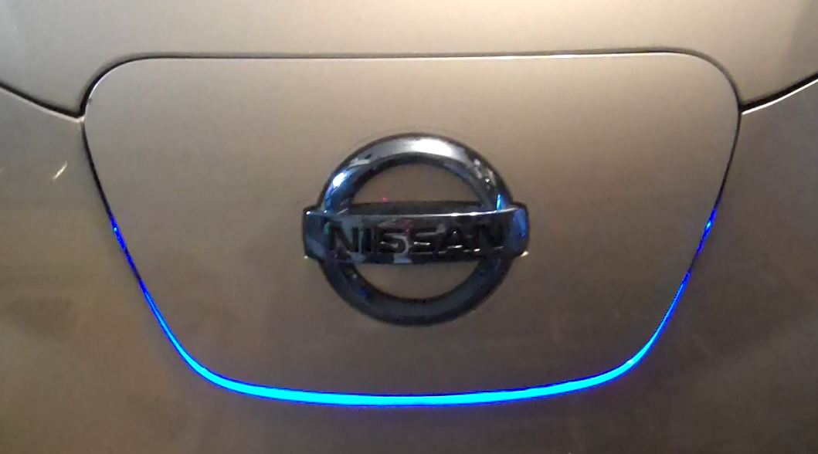
Disclaimer: I hope many people use this guide and do this project. I refrained from cutting or drilling anything, and it can easily be removed. If you decide to do this easy project, I take no responsibility if you damage you vehicle (though I don’t see how)
If you have any questions/comments, please email me
Travis Kerzic
travis@kerzic.com
Parts List:
Custom Accessories 10” LED Flex Lights
http://www.amazon.com/Custom-Accessories-23759-Running-Square/dp/B009IK8AKK
Bussman inline fuse holder
http://www.autozone.com/autozone/accessories/Cooper-Bussmann-ATM-in-line-fuse-holder/_/N-25gq?itemIdentifier=32420_0_0_
1-5A Bussman fuse
http://www.autozone.com/autozone/parts/Bussmann-Fuse/_/N-8gd05?itemIdentifier=32367_0_0_
Micro Switch
http://www.radioshack.com/product/index.jsp?productId=2049718&znt_campaign=Category_CMS&znt_source=CAT&znt_medium=RSCOM&znt_content=CT2032230
Here is a basic circuit of the project.
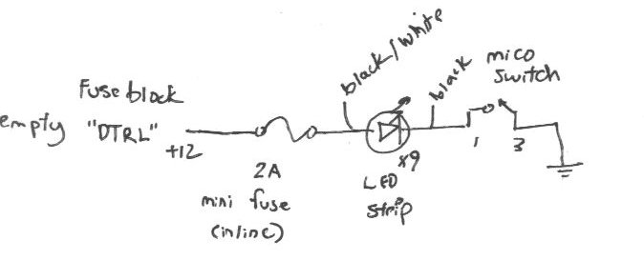
The switch will connect ground and complete the circuit. This will also minimize any water problems, if it gets wet. I added the fuse just in case the wire gets crimped by something (better safe than sorry).

Step 1 Hook Up the Switch:
First cut the LED strip on the last white cut line. There should be 9 LEDs left.
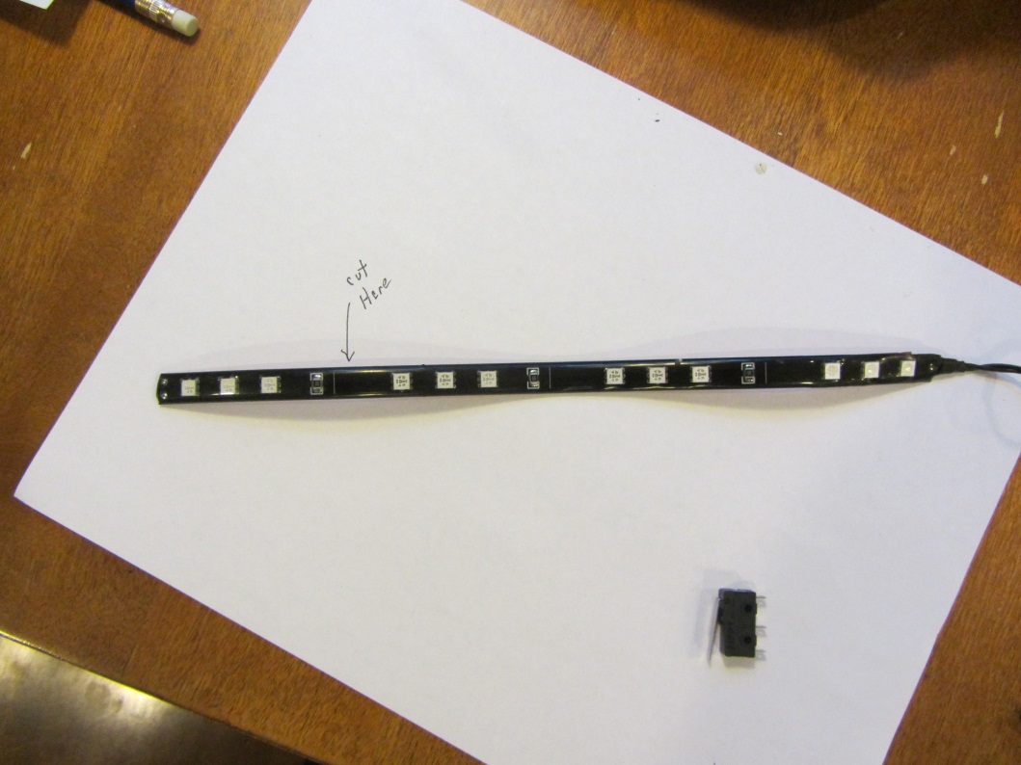
Now Cut the BLACK ground wire about 2 in from the end of the strip. Separate the wires so that you have some room to solder or crimp. 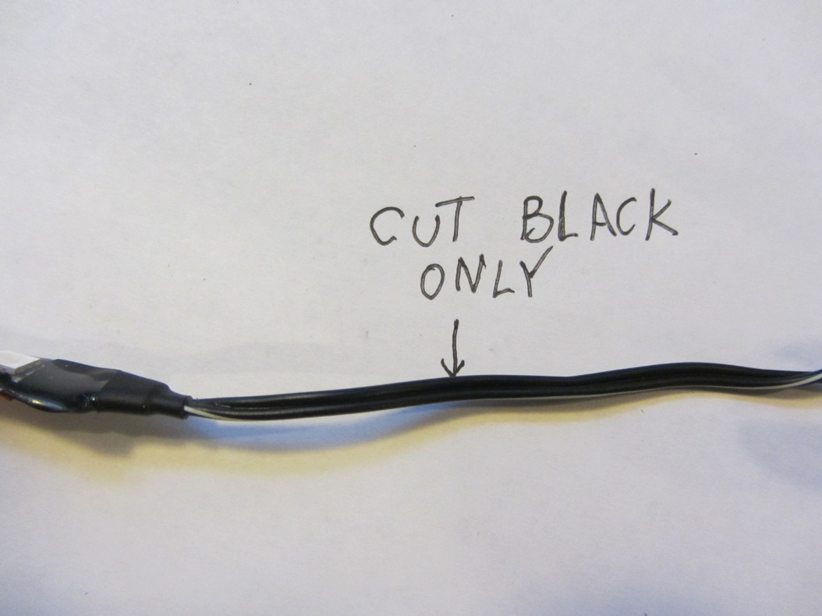
Now wire in the switch.
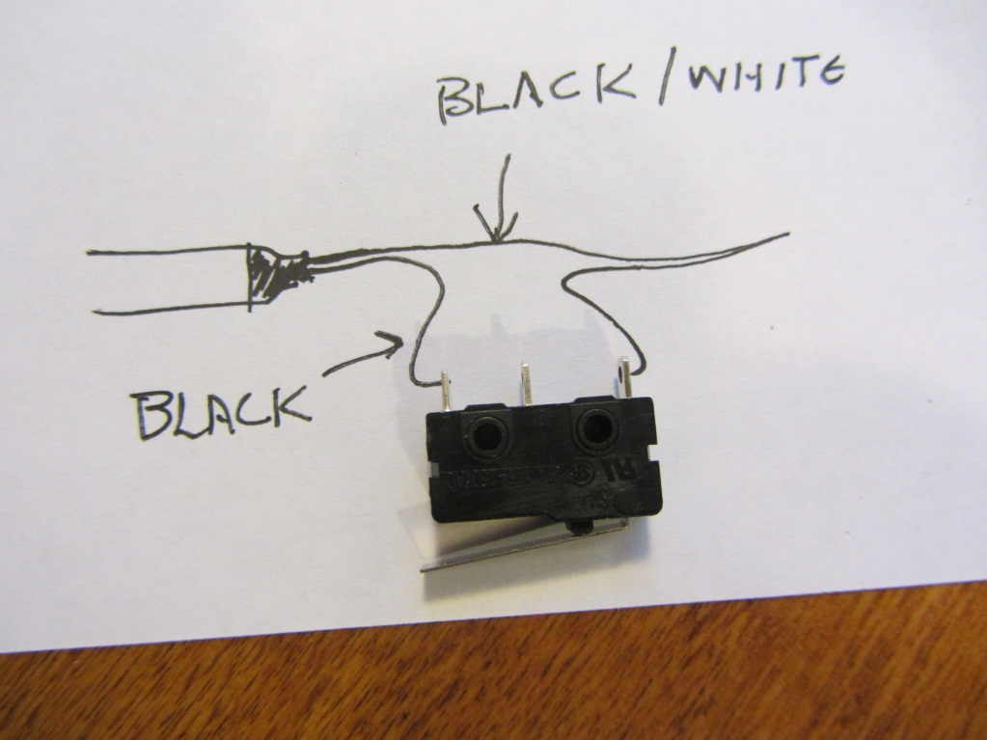
You can use crimp connectors, but I prefer soldering. I’ve had many a connection fail due to oxidation, and it can get pretty wet under there. I also put shrink wrap on the terminals, just cause I’m paranoid.
Step 2 snake the wire
Now for the tricky part, you have to run through the little drain hole on the right side.
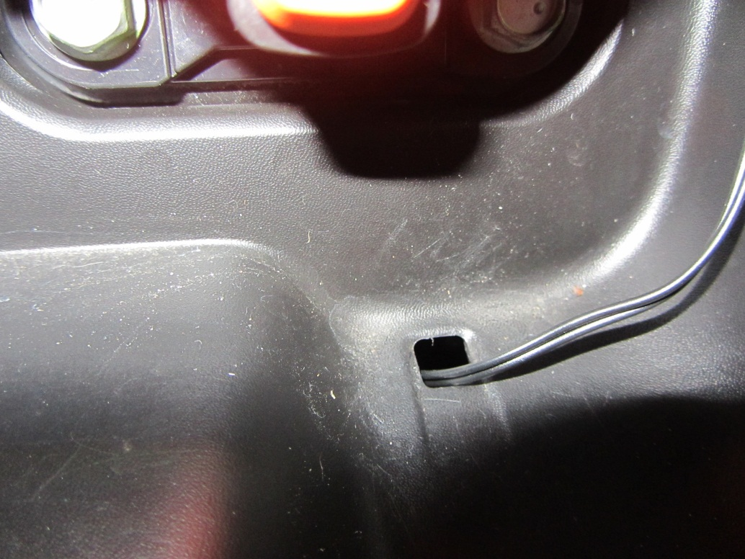
I tried using the LED wire, but it was not stiff enough, and I never could find it. I ended up taking a stiffer solid wire, running that though the hole. Once I had it on the inside, I taped the LED wire to it, and gently pulled it through. I had to pull down first because it kept getting caught on corner.
Step 3 Hook up the Power:
I found an unused block in the fuse area.
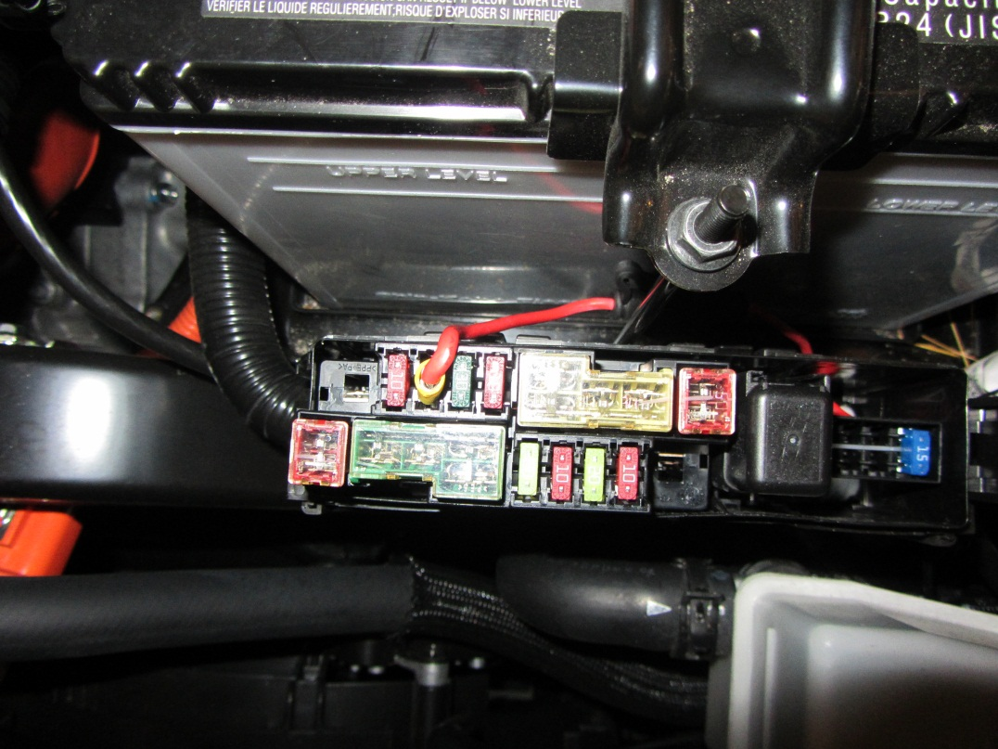
It’s labeled “DTRL”, there are also 2 empty fuses on the right side with similar DTRL labels, but they didn’t have the power routed them. In order to make a connector that was fuse sized, I took one of these…
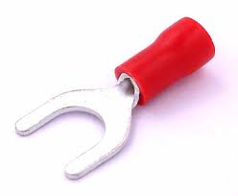
…trimmed half the connector off, to make it fuse shaped, and then cut some of the collar off, so it would not protrude above the fuses.
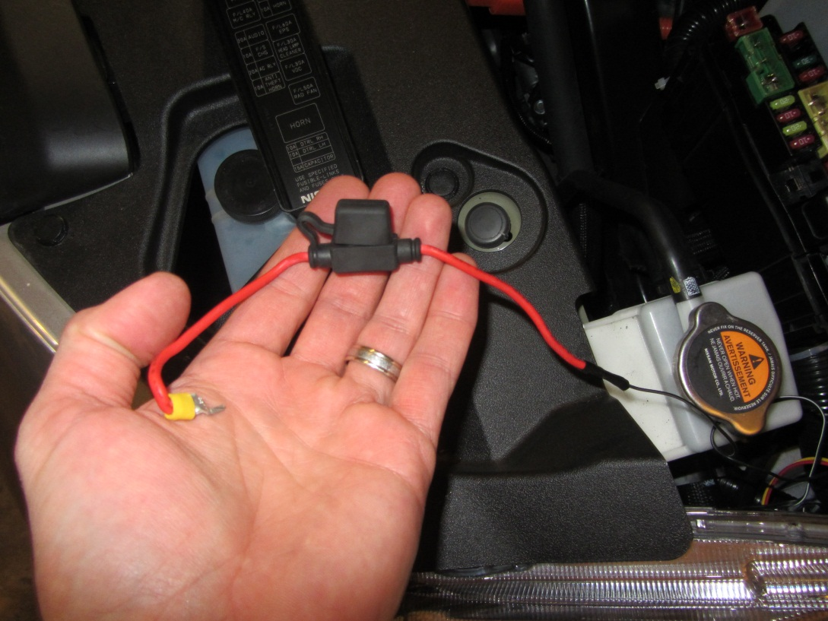
I then wired it to the black/white +12v wire. Use shrink wrap if you got it.
Next I hooked the ground to the chassis ground on the right wheel well. It’s a 10mm bolt. I put a split connector on it, and slid it under the bolt like so…
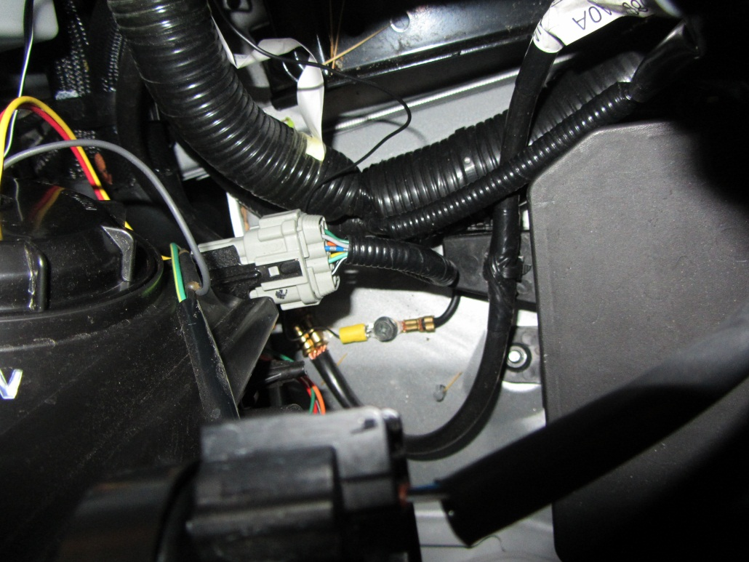

Step 4 Mount It:
Now to mount the LEDs and switch…
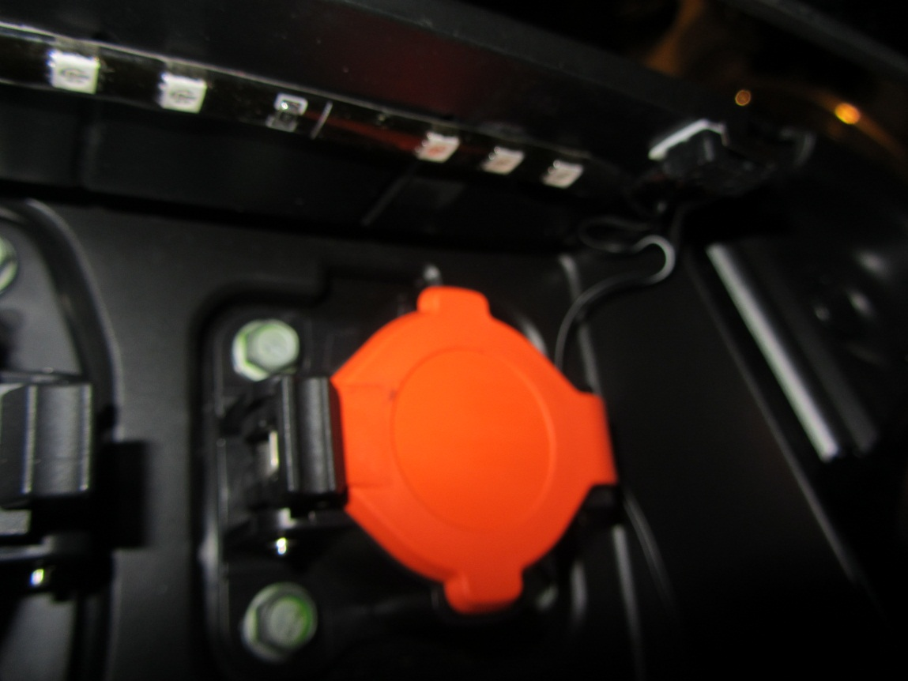
Peel the back off the LED strip. Stick it on the plastic water shield about 1” back, so that the switch has some room. Now mount the switch with some double stick (I may change this out to a bolt, if it decided to move, but it’s fairly light duty, so we’ll see).
It should stick out this much…
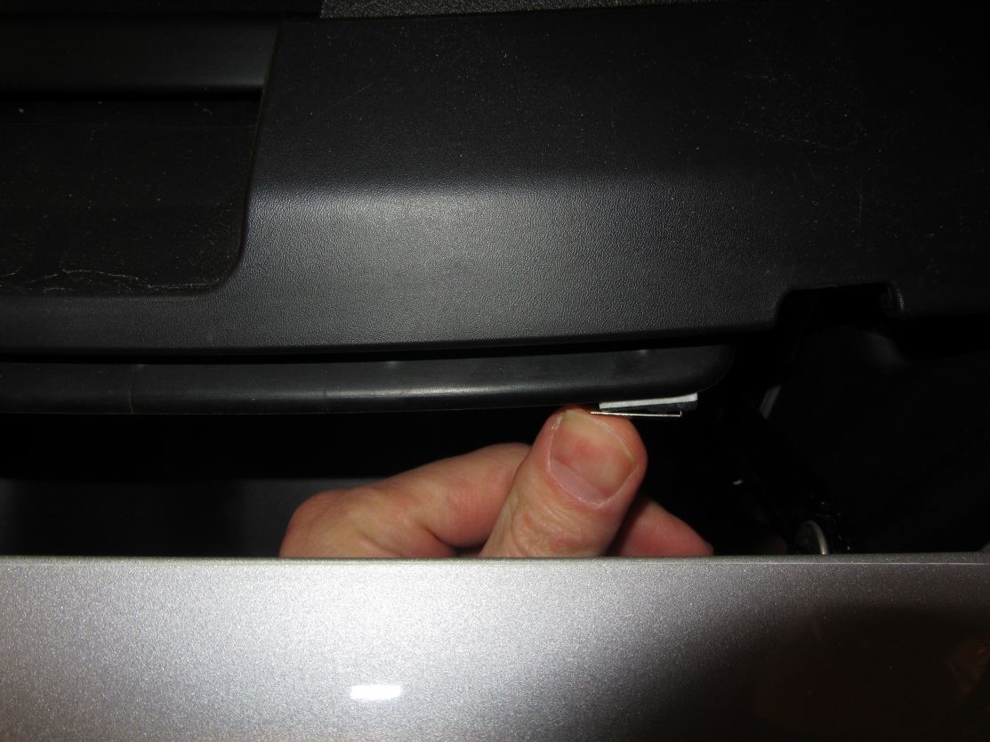
Once everything is hooked up, test it out!
Enjoy!
Addendum:
You may notice that the charge plug rubs a little bit on the LED strip. I have to push it with a little force sometimes. I’m looking for a strip that has a thinner waterproof seal on top of it. I’ll update this doc if I do. I thought about moving them to the back of the charge port, but then the ports would be backlit, which I didn’t want. I’m also considering removing the waterproof strip, and applying a plastic spray on top. If anyone finds a thinner strip, please let me know. Thickness seems to be the one spec they don’t put on these things.

